## Before running the main.py file, you need to do some changes with the file.

### IN main.py file the changes are mentioned below:

replace the below code directory to your actual database of MS Access

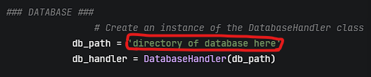

And now in the same main.py file you need to place the Api key of google maps and open weather.

And the last replacement come here.

You need to replace you vs code.exe path below:  
